Performance of a long short-term memory (LSTM) model for daily temperature and humidity forecasting over New Delhi, India.

Bilikis A. Alege-Ibrahim¹, Tahir A. Alaka¹ Ibrahim Alege², Habeebullah M. Alege³,

¹National Weather Forecasting and Climate Research Center, Nigerian Meteorological Agency, Abuja, Nigeria
²Nile University of Nigeria
³Nigerian Airspace Management Agency, Nnamdi Azikiwe International Airport, Abuja, Nigeria
Correspondence to: Bilikis Alege-Ibrahim (alegebilqees@gmail.com)

Keywords: Long short-term memory (LSTM); temperature forecasting; humidity forecasting; time series prediction; machine learning; New Delhi

Abstract

Accurate forecasting of near-surface temperature and humidity is essential for weather-sensitive applications in urban environments. This study evaluates the performance of a long short-term memory (LSTM) model for daily temperature and relative humidity forecasting over New Delhi, India, using long-term observational data. Model skill was assessed using mean absolute error, root mean square error, and the coefficient of determination, and compared against naïve persistence and moving-average benchmarks. Results show that the LSTM model captures temporal variability effectively and consistently outperforms baseline methods for both variables. These findings demonstrate the potential of LSTM-based models for short-range urban weather forecasting.

- Introduction
Weather forecasting is fundamental to socio-economic activities such as agriculture, energy management, public health and urban planning. Among near-surface meteorological variables, air temperature and relative humidity are particularly important due to their influence on thermal comfort, heat stress, air quality, and infrastructure performance, especially in densely populated urban environments (Shrivastava et al., 2012; Peng et al., 2023).
Conventional weather prediction relies primarily on numerical weather prediction (NWP) models, which are based on physical representations of atmospheric processes. Despite their success, NWP models are constrained by uncertainties in initial conditions, parameterization schemes, and computational costs, which can limit forecast skill at local and urban scales (Michaelides et al., 2001; Holmstrom et al., 2016). As a result, statistical and empirical forecasting approaches continue to play an important complementary role in applied meteorology.
In recent years, machine learning techniques have gained prominence as data-driven alternatives for time-series forecasting. These approaches learn complex, nonlinear relationships directly from historical observations and have shown promise in meteorological applications where traditional models struggle (LeCun et al., 2015; Li et al., 2022). Recurrent neural networks (RNNs) are particularly suited to sequential data; however, their ability to capture long-term temporal dependencies is often limited by the vanishing gradient problem during training (Hochreiter and Schmidhuber, 1997). Long short-term memory (LSTM) networks were developed to overcome this limitation by introducing gated memory cells that regulate information flow through time. This architecture enables LSTM models to retain relevant historical information over extended sequences, making them well suited for atmospheric and climate time-series forecasting (Kim et al., 2018; Van Houdt et al., 2020). Numerous studies have demonstrated the effectiveness of LSTM-based models for predicting temperature and humidity across different climatic regions and temporal scales (Jia et al., 2022; Peng et al., 2023).
Urban climates present additional forecasting challenges due to land-use heterogeneity, anthropogenic heat emissions, and strong seasonal variability. New Delhi, one of the world’s largest megacities, experiences extreme summer temperatures, pronounced monsoon-driven humidity variability, and sharp seasonal transitions. These characteristics make the region an appropriate testbed for evaluating data-driven forecasting techniques under complex urban climatic conditions. This study applies an LSTM-based deep learning framework to forecast daily temperature and relative humidity over New Delhi using long-term observational data. The model integrates systematic data preprocessing, time-aware feature engineering, and rigorous performance evaluation. Forecast skill is assessed using standard statistical metrics and benchmarked against naïve persistence and moving-average forecasting methods. The findings provide insight into the capability of LSTM models to enhance empirical urban weather forecasting and their potential role as complementary tools within applied meteorological practice.
- Data and study area
  - Study Area
New Delhi, the capital territory of India, is located in northern India at approximately 28.7° N, 77.1° E. The geographical location of the study area is shown in Figure 1. The city lies inland, away from maritime influences for much of the year, and is characterized by a continental climate with strong seasonal variability. Four distinct seasons are typically observed: winter (December–February), pre-monsoon summer (March–June), monsoon (July–September), and post-monsoon transition (October–November).
New Delhi experiences extreme summer temperatures, frequently exceeding 40 °C during heatwave events, while winter temperatures can fall below 5 °C under the influence of continental air masses. Relative humidity exhibits strong seasonal modulation, with high values during the monsoon months and substantially lower values during the pre-monsoon period. These pronounced thermal and moisture contrasts, combined with rapid urbanisation and anthropogenic heat effects, make New Delhi a challenging environment for local-scale weather forecasting and an appropriate case study for evaluating data-driven prediction models (Michaelides et al., 2001; Shrivastava et al., 2012).

2.2 Data
This study uses long-term daily meteorological observations for New Delhi spanning January 1997 to December 2016, obtained from an openly available weather archive (Kaggle). The original dataset contains multiple meteorological parameters, including wind, pressure, precipitation, and visibility variables.
Following quality control and completeness checks, only air temperature and relative humidity were retained for analysis, as these variables contained sufficiently continuous records and are directly relevant to thermal comfort and urban climate assessment. Variables with more than 75 % missing values were excluded to ensure data reliability. The final dataset consists of daily mean temperature (°C) and daily mean relative humidity (%), along with corresponding timestamps.
Missing values within the retained variables were addressed using interpolation to preserve temporal continuity. The time series was subsequently indexed by date, enabling the extraction of time-dependent features. To represent the cyclic nature of diurnal and annual variability, sinusoidal transformations of time were applied, allowing the model to capture periodic seasonal behaviour without introducing discontinuities at temporal boundaries (Priatna and Djamal, 2020; Jia et al., 2022).

Methods

3.1 Data Preprocessing
Daily temperature and relative humidity observations were first subjected to basic quality control. Missing values within the retained variables were addressed using interpolation to ensure temporal continuity of the time series. The datetime field was converted to a continuous time index to facilitate sequential modelling.
To account for the strong cyclic nature of meteorological variables, time-based features were engineered using sinusoidal transformations. Sine and cosine representations of the day-of-year and time-of-day were derived, enabling the model to capture seasonal and periodic behaviour without introducing artificial discontinuities at cycle boundaries (Priatna and Djamal, 2020; Jia et al., 2022).
The dataset was transformed into supervised learning format using a sliding window approach, where sequences of seven consecutive time steps were used as model inputs and the subsequent day’s temperature and humidity values served as prediction targets. The full dataset was divided chronologically into training (70 %), validation (15 %), and testing (15 %) subsets to ensure robust evaluation on unseen data.
Prior to model training, temperature and humidity values were normalised using min–max scaling, based solely on statistics from the training dataset. This step ensured numerical stability and improved convergence during optimisation.

3.2 LSTM Model Architecture
Forecasting was performed using a long short-term memory (LSTM) neural network implemented within a deep learning framework. LSTM networks are well suited for time-series prediction due to their ability to capture long-term temporal dependencies while mitigating vanishing gradient issues common in standard recurrent neural networks (Hochreiter and Schmidhuber, 1997; Kim et al., 2018).
The model architecture consisted of two stacked LSTM layers, each containing 64 hidden units. The first LSTM layer returned full sequences to preserve temporal information, while the second produced a condensed representation of learnt dependencies. A dropout layer was applied to reduce overfitting by randomly deactivating neurons during training. The output stage comprised fully connected dense layers, producing simultaneous predictions of temperature and humidity.
All model parameters were trainable, with a total of approximately 51,700 parameters, allowing sufficient flexibility to capture nonlinear atmospheric patterns without excessive complexity.

3.3 Model Training and Optimisation
The model was trained using the Adam optimisation algorithm, selected for its adaptive learning rate and efficiency in deep learning applications. Mean squared error was used as the loss function, appropriate for continuous-valued regression tasks. Model performance during training was monitored using the root mean square error (RMSE).
Training was conducted for 10 epochs, with a checkpointing strategy employed to retain the model state that achieved the lowest validation error. This approach helped prevent overfitting while preserving optimal generalisation performance.
To further improve forecast accuracy, hyperparameter tuning was conducted using a grid search strategy. Learning rate and dropout rate were systematically varied, and the optimal configuration was selected based on validation performance. This tuning process resulted in measurable improvements in both temperature and humidity predictions.
3.4 Model Evaluation and Benchmarking
Model performance was evaluated using standard statistical metrics: mean absolute error (MAE), root mean square error (RMSE), and the coefficient of determination (R²). These metrics provide complementary insights into forecast accuracy, error magnitude, and goodness of fit.
To place the LSTM model’s performance in context, results were benchmarked against two baseline approaches: naïve persistence forecasting and a moving average method. Comparisons against these baselines allow assessment of the added value provided by the LSTM framework beyond simple statistical predictors.
- Results
4.1 Temperature Forecasting Performance
The LSTM model demonstrated strong skill in forecasting daily mean air temperature over New Delhi. Evaluation on the independent test dataset yielded a mean absolute error (MAE) of 1.51 °C, a root mean square error (RMSE) of 2.16 °C, and a coefficient of determination (R²) of 0.93, indicating a high level of agreement between predicted and observed values (Table 1).
Visual comparison of predicted and observed temperature time series shows that the LSTM model successfully captures the dominant temporal variability and seasonal structure. While short-term deviations are present, the predicted values closely follow observed temperature trends, including periods of rapid warming and cooling (Figure 2).
Residual analysis indicates that temperature errors are generally symmetrically distributed around zero, suggesting minimal systematic bias. The majority of residuals fall within a narrow range, although occasional larger errors occur during periods of elevated temperature variability, likely associated with extreme weather conditions.

4.2 Humidity Forecasting Performance
For relative humidity, the LSTM model achieved an MAE of 6.94 %, an RMSE of 9.52 %, and an R² of 0.83 on the test dataset Table 1. Although forecast errors are larger than temperature, the model retains substantial explanatory power, reflecting the greater intrinsic variability and non-linearity of humidity processes.
Time-series comparison reveals that the model captures the overall evolution and seasonal modulation of humidity, particularly during monsoon and post-monsoon periods. Larger discrepancies are observed during transitional seasons, where humidity exhibits rapid fluctuations (Figure 3).
Residual distributions for humidity show a broader spread compared to temperature, with values extending towards both positive and negative extremes. Nevertheless, the residuals remain centred near zero, indicating the absence of persistent over or under estimation.

4.3 Benchmark Comparison
To assess the added value of the LSTM framework, model performance was compared against two baseline forecasting approaches: naïve persistence and moving average methods.
For temperature, the LSTM model outperformed both baseline methods, reducing RMSE by approximately 32 % relative to naïve forecasting and by 54 % compared with the moving average approach. Similarly, R² values increased from 0.85 (naïve) and 0.67 (moving average) to 0.93 with the LSTM model (Table 1).
For humidity, performance gains were also evident. The LSTM model reduced RMSE by approximately 30 % relative to naïve forecasting and by nearly 49 % compared with the moving average method. Improvements in R² further confirm the enhanced explanatory capability of the LSTM approach (Table 1).

4.4 Impact of Hyperparameter Tuning
Hyperparameter optimisation resulted in additional improvements in forecast accuracy. After tuning the learning rate and dropout rate, temperature forecast performance improved to an MAE of 1.19 °C, an RMSE of 1.88 °C, and an R² of 0.95. For humidity, modest gains were also observed, with MAE reduced to 6.70 % and R² increasing to 0.84.
These results highlight the sensitivity of LSTM performance to training configuration and demonstrate the importance of systematic optimisation in achieving robust forecasts.

- Discussion
The results demonstrate that the LSTM-based forecasting framework provides substantial improvements over simple statistical baselines for daily temperature and humidity prediction in New Delhi. The strong performance for temperature forecasts, with R² values exceeding 0.9, indicates that the model effectively captures dominant temporal patterns and seasonal variability present in the observational record. This aligns with previous studies that have highlighted the suitability of LSTM architectures for meteorological time series characterised by persistence and periodicity (Kim et al., 2018; Van Houdt et al., 2020).
Humidity forecasts exhibit comparatively larger errors, which are consistent with the inherently higher variability and sensitivity of atmospheric moisture to local scale processes such as convection, land-atmosphere interactions, and monsoon dynamics. Despite this, the LSTM model still achieves a clear improvement over naïve persistence and moving average methods, confirming its ability to learn nonlinear dependencies that are not well represented by simpler approaches.
The benchmarking results emphasise the added value of deep learning models in urban weather applications. While baseline methods rely primarily on short-term persistence, the LSTM framework leverages longer historical context through its memory structure, enabling more robust forecasts during periods of rapid transition. The observed performance gains following hyperparameter tuning further underline the importance of careful model optimisation in applied forecasting studies.
From an operational perspective, these findings suggest that LSTM-based models can serve as effective empirical complements to traditional numerical weather prediction systems, particularly where high-resolution local forecasts are required or computational resources are limited. However, the results also highlight limitations associated with data quality, nonlinearity, and extreme events, indicating that machine learning approaches should be integrated thoughtfully rather than viewed as standalone replacements for physically based models.

- Conclusion

This study investigated the application of a long short-term memory neural network for daily temperature and humidity forecasting over New Delhi, India, using long-term observational data. Through systematic data preprocessing, time-aware feature engineering, and rigorous evaluation, the LSTM model demonstrated strong predictive skill, particularly for temperature, and consistently outperformed naïve and moving average forecasting approaches.

Hyperparameter optimisation resulted in further improvements in forecast accuracy, reinforcing the sensitivity of deep learning models to training configuration. While humidity prediction remains more challenging due to its intrinsic variability, the LSTM framework still provided meaningful gains relative to baseline methods.

Overall, the results confirm the potential of LSTM-based models as valuable tools for empirical urban weather forecasting. When used alongside conventional approaches, such models can enhance short-range predictive capability and support weather-sensitive decision-making in complex urban environments. Future work should explore the integration of additional meteorological variables, longer forecast horizons, and hybrid frameworks combining machine learning with numerical weather prediction outputs.

Acknowledgements
The authors acknowledge the use of meteorological datasets obtained from Kaggle. The authors also acknowledge the institutional support provided by the Nigerian Meteorological Agency (NiMet).

Funding Statement
This research received no external funding.

Conflict of Interest Statement
The authors declare no conflict of interest.

Ethical Approval
Not applicable.
References

Agada, M. U., Bashir, S. A. & Adepoju, S. A. (2021) Multidimensional time-series weather prediction using long short-term memory neural networks. Proceedings of the 14th International Multi-Conference on ICT Applications.

Holmstrom, M., Liu, D. & Vo, C. (2016) Machine learning applied to weather forecasting. Meteorological Applications, 23, 1–5.

Hochreiter, S. & Schmidhuber, J. (1997) Long short-term memory. Neural Computation, 9, 1735–1780.

Jia, X., Li, J., Li, H. & Zhang, Y. (2022) Prediction of sea surface temperature using LSTM neural networks. Remote Sensing, 14, 3300.

Kim, K., Lim, S., Kim, S. & Lee, J. (2018) Stable forecasting of environmental time series via long short-term memory recurrent neural networks. IEEE Access, 6, 75216–75228.

LeCun, Y., Bengio, Y. & Hinton, G. (2015) Deep learning. Nature, 521, 436–444.

Li, X., Wang, J. & Zhang, Y. (2022) Construction and simulation of decision models based on recurrent neural networks. Journal of Mathematics, 2022, 1–11.

Michaelides, S. C., Pattichis, C. S. & Kleovoulou, G. (2001) Classification of rainfall variability using artificial neural networks. International Journal of Climatology, 21, 1401–1414.

Peng, F.-L., Qiao, Y.-K. & Yang, C. (2023) LSTM-RNN-based intelligent control of temperature and humidity in urban utility tunnels. Heliyon, 9, e13492.

Priatna, M. A. & Djamal, E. C. (2020) Precipitation prediction using recurrent neural networks and long short-term memory. TELKOMNIKA, 18, 2525–2532.

Shrivastava, G., Karmakar, S., Kowar, M. K. & Guhathakurta, P. (2012) Application of artificial neural networks in weather forecasting: a comprehensive review. International Journal of Computer Applications, 51, 17–29.

Van Houdt, G., Mosquera, C. & Napoles, G. (2020) A review on the long short-term memory model. Artificial Intelligence Review, 53, 5929–5955.

Table

Table 1: Summary of LSTM forecast performance for daily temperature and relative humidity
Metric | MAE | RMSE | R-Square
Temperature (ºC) | 1.51 | 2.16 | 0.93
Humidity (%) | 6.94 | 9.52 | 0.83

Figures
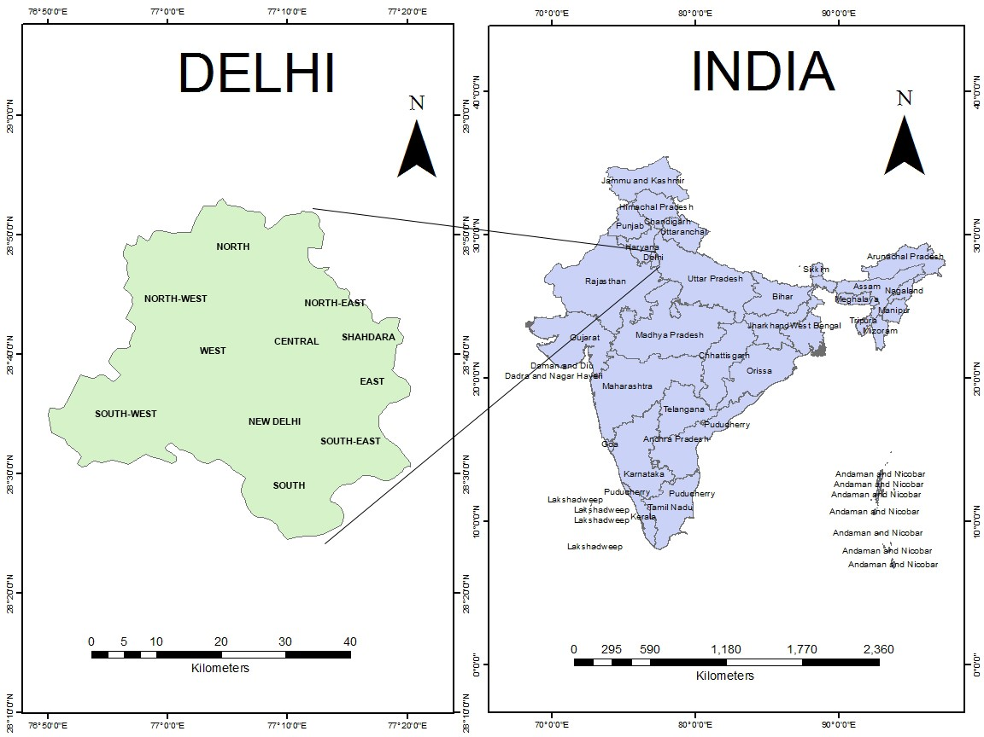
Figure 1: Location of New Delhi, India, showing the study area used for daily temperature and humidity forecasting.

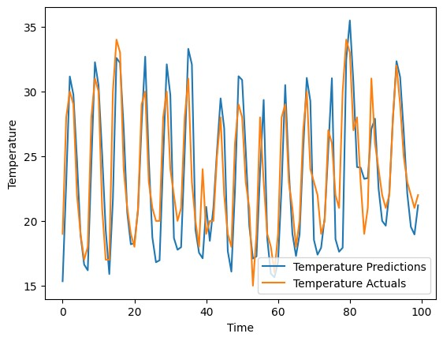
Figure 2: Comparison of observed and LSTM-predicted daily mean temperature over the test period.

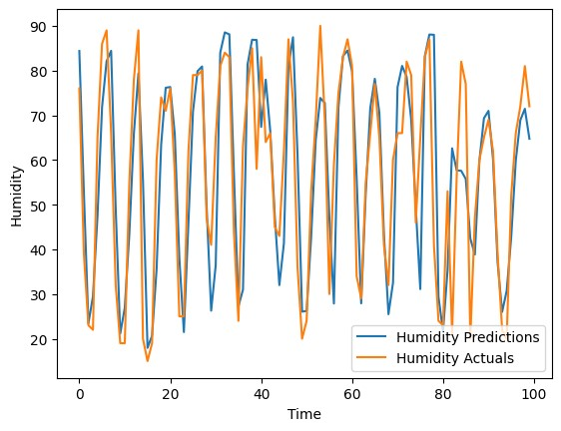
Figure 3: Comparison of observed and LSTM-predicted daily mean relative humidity over the test period

